भारत मौसम विज्ञान विभाग |  | India Meteorological Department
Wednesday 13th May 2026 (23rd Vaisakha 1948 Saka)
Summary of observations recorded at 0830 hours IST: Conditions are becoming favourable for the advance of southwest monsoon over parts of south Bay of Bengal, Andaman Sea and Andaman & Nicobar Islands around 16th May, 2026. The low-pressure area over southwest Bay of Bengal moved northeast wards and lay over southwest adjoining westcentral Bay of Bengal at 0530 Hrs IST of today, the 13th May 2026, with the associated cyclonic circulation extending upto 4.5 km above m. s. l. It then lay as a well-marked low-pressure area over the same region at 0830 Hrs IST of today, the 13th May 2026, with the associated cyclonic circulation extending upto 5.8 km above m. s. l. The Western Disturbance as an upper air cyclonic circulation over North Pakistan & neighbourhood lay over Jammu at 3.1 km above m. s. l. An upper air cyclonic circulation lay over south Haryana & neighbourhood at 0.9 km above m. s. l. An upper air cyclonic circulation lay over northwest Uttar Pradesh & adjoining Uttarakhand at 0.9 km above m. s. l. The upper air cyclonic circulation over Southwest Madhya Pradesh & neighbourhood persisted and seen at 0.9 km above m. s. l. at 0530 hrs IST of today morning. It then persisted over the same region. The trough from upper air cyclonic circulation over Southwest Madhya Pradesh to Manipur trough ran from upper air cyclonic circulation over Southwest Madhya Pradesh to north Chhattisgarh at 0530 hrs IST of today morning. It ran from upper air cyclonic circulation over Southwest Madhya Pradesh to Manipur across East Madhya Pradesh, south Bihar, north Gangetic West Bengal, and South Assam at 0.9 km above m. s. l. A trough in westerly ran roughly along Long. 89°E to the north of Lat. 22°N at 3.1 km above m. s. l. at 0530 hrs IST of today morning. It then persisted over the same region. A north-south trough ran from Southwest Madhya Pradesh to South Interior Karnataka across Madhya Maharashtra, North Interior Karnataka upto 1.5 km above m. s. l. A fresh Western Disturbance is likely to affect Northwest India from 15th May 2026. The trough in easterlies from the centre of low-pressure area over Southwest Bay of Bengal ran from the centre of low-pressure area over southwest adjoining westcentral Bay of Bengal to Comorin area at 0530 hrs IST of today morning. It became less marked. The upper air cyclonic circulation over West Rajasthan & neighbourhood became less marked. The trough from East Arunachal Pradesh to North Bay of Bengal ran roughly along Long. 93°E to the north of Lat. 22°N at 0530 hrs IST of today morning. The upper air cyclonic circulation over North central Uttar Pradesh & neighbourhood became less marked at 0530 hrs IST of today morning.
Maximum Temperature Departures (as on 12-05-2026): markedly above normal (> 5.1°C) at most places over West Rajasthan and East Rajasthan; at few places over West Madhya Pradesh, Gujarat Region, Marathwada and Vidarbha; at isolated places over East Madhya Pradesh and Madhya Maharashtra. appreciably above normal (3.1°C to 5.0°C) at many places over Punjab, Himachal Pradesh and Jammu-Kashmir-Ladakh-Gilgit-Baltistan-Muzaffarabad; at most places over Arunachal Pradesh; at few places over Haryana-Chandigarh-Delhi and Saurashtra & Kutch; at isolated places over Assam & Meghalaya, Gangetic West Bengal, Konkan & Goa, Chhattisgarh, Coastal Andhra Pradesh & Yanam and Telangana. above normal (1.6°C to 3.0°C) at many places over North Interior Karnataka; at few places over Jharkhand; at isolated places over Odisha, East Uttar Pradesh, Uttarakhand, Tamil Nadu, Puducherry & Karaikal and Kerala & Mahe. near normal (-1.5°C to 1.5°C) at many places over Nagaland, Manipur, Mizoram & Tripura, Sub Himalayan West Bengal & Sikkim and West Uttar Pradesh; at most places over Rayalaseema, Coastal Karnataka, South Interior Karnataka and Lakshadweep; at few places over Andaman & Nicobar Islands and Bihar. The highest maximum temperature of 47.3°C was reported at Barmer (Rajasthan).
Preliminary Earthquake Report: An earthquake shock of Slight intensity at its origin with epicenter at Lat. 18.511° North and Long. 73.751°East, 10 km above m. s. l. W of Pune; Maharashtra; India; about 12 kms away from Pune, was recorded by the seismographs in the meteorological Office Pune at 14 Hrs. 20 Min. 50 Secs. IST on 12-05-2026 having its magnitude 2.4 on the Richter scale.
Preliminary Earthquake Report: An earthquake shock of Slight intensity at its origin with epicenter at Lat. 19.616° North and Long. 77.133°East, 265 km above m. s. l. SW of Hingoli; Nagpur; Maharashtra; India; about 364 kms away from Pune, was recorded by the seismographs in the meteorological Office Pune at 18 Hrs. 27 Min. 48 Secs. IST on 12-05-2026 having its magnitude 3.4 on the Richter scale.
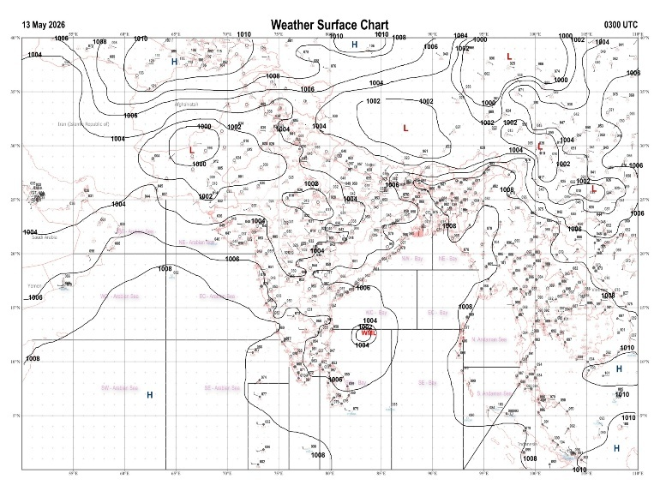 | 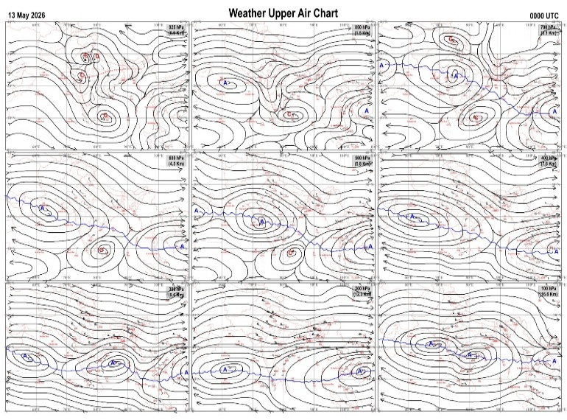
Fig.1. Analysed surface chart based on 03z observation | Fig.2. Analysed upper air chart based on 00z observation
Dr. S.D.Sanap
Scientist ‘D’
CR & S Office, Pune  Issued at 1245 hrs. IST |  | Weather Forecasting Division  CR&S, Pune

Indian regions | Realised rainfall (chief amount in cm during past 24 hrs):
East | a few places: Assam & Meghalaya+, Sub-Himalayan West Bengal & Sikkim+ and Bihar+  isolated places: Arunachal Pradesh, Nagaland-Manipur-Mizoram-Tripura, Gangetic West Bengal+, Odisha and Jharkhand  Krityanand Nagar 11.5, Bhaghmara & Tadong 10.3 each, Nalhati 9.8, Gangtok 8.2, Banmankhi 6.8, Williamnagar 6.5, Murarai 5.5, Barkote, Amrapara & Purnea 5.2 each, Kharsema 4.8, Dhubri IMD 4.0, Telkoi 3.8, Mekhliganj 2.8, Keonjhargarh 2.2, Berhampore 2.0, Chaibasa 1.7, Kolasib AWS 1.4, Tuting 1.0, Deomali AWS 0.7, Mokokchang 0.3.
North | a few places: Jammu-Kashmir and Ladakh  isolated places: Uttar Pradesh, Uttarakhand, Haryana, Punjab◆, Himachal Pradesh and Rajasthan  Churu tehsil SR & Churu 3.0 each, Bilari & Ukhimath 2.0 each, Milak 1.6, Moradabad & Kukumsheri AWS 1.3 each, Sama 1.2, Bari 1.1, Baseri SR 1.0, Malangpura AWS & Gulmarg AWS 0.9 each, Shoharatgarh 0.7, Munsiyari, Pataudi, Madluda REV, Seo bagh & Pahalgam 0.5 each, Alwar obs 0.4, Gurgaon REV 0.1.
Central | isolated places: Madhya Pradesh and Chhattisgarh◆  dry weather: Vidarbha  Alipur (jaura) & Prithvipur 0.4 each, Morena-aws 0.3, Manpur & Mohla 0.2 each, Gwalior 0.1.
Peninsula | many places: coastal Karnataka+  a few places: Kerala  isolated places: Konkan & Goa◆, Madhya Maharashtra, Marathwada, coastal Andhra Pradesh, Telangana, Rayalaseema, Tamil Nadu and interior Karnataka  dry weather: Gujarat State  Mangaluru 7.9, Ranni AWS & Chemberi AWS 4.9 each, Shakti Nagar 4.7, Punalur 4.2, Oothu 3.3, Nalumukku 2.9, Yellapur 2.8, Agumbe AWS 2.7, Partur 2.3, Yellandu 2.0, Bhagamandala & Kottigehara 1.8 each, Dharwad PTO 1.5, Shiggaon 1.3, Raibagh 1.2, Garla 1.1, Bhadrachalam & Valparai PTO 0.7 each, Dhone 0.6, Peapally 0.5, Lonavala ARG & Chintapalle 0.3 each, Ratnagiri , Akalkot & Sholapur 0.2 each, Canacona 0.1.
Islands | most places: Andaman & Nicobar  a few places: Lakshadweep  Iaf carnicobar 5.1, Nancowry 4.6, Maya bandar 3.8, Minicoy 1.5.
Table-2 Forecast / warnings (distribution of rain / thundershowers) for 7 days (valid from time of origin upto 0830 hrs IST of next day)
Sr N. |  | Sub-division Name | Day 1 | Day 2 | Day 3 | Day 4 | Day 5 | Day 6 | Day 7 | Sr. No. | Sub-division Name | Day 1 | Day 2 | Day 3 | Day 4 | Day 5 | Day 6 | Day 7
 |  |  | 13 May | 14 May | 15 May | 16 May | 17 May | 18 May | 19 May |  |  | 13 May | 14 May | 15 May | 16 May | 17 May | 18 May | 19 May
 | 1 | Andaman Nicobar Islands | W + | W+ | W+ | W+ | W+ | W+ | W+ | 19 | west Madhya Pradesh | D  + | D + | D + | D + | D + | D | D
 | 2 | Arunachal Pradesh | S + | F ++ | S + | F + | F + | F ++ | S | 20 | east Madhya Pradesh | D  | D | D + | D + | D + | D | D
 | 3 | Assam-Meghalaya | W ++ | W++ | W+ | W+ | F + | F + | F + | 21 | Gujarat region | D + | D + | D | D | D | D | D
 | 4 | Nagaland-Manipur-Mizoram-Tripura | S + | F+ | F + | S | S | F + | F + | 22 | Saurashtra and Kutch | D + | D + | D | D | D | D | D
 | 5 | Sub Him West Bengal/Sikkim | W ++ | W + | F+ | F+ | F | S | S | 23 | Konkan and Goa | I+ | I + | D | D | D | I | I
 | 6 | Gangetic West Bengal | S | S | I | I | I | I | I | 24 | Madhya Maharashtra | I+ | I + | I | I | I | D | D
 | 7 | Odisha | I | I | I | I | I | I | I | 25 | Marathwada | I+ | D + | D | D | D | D | D
 | 8 | Jharkhand | I | I | I | S | I | I | I | 26 | Vidarbha | I+ | D + | D + | D + | D + | D+ | D+
 | 9 | Bihar | I | I | I | S | I | I | I | 27 | Chhattisgarh | I  | I  | I  | I  + | I  + | I + | I +
 | 10 | east Uttar Pradesh | I | D | D | D + | D + | D + | D + | 28 | Coastal Andhra Pradesh and Yanam | I  | I  | I  | I  | I  | I | I
 | 11 | west Uttar Pradesh | I | D | D | D + | D + | D + | D + | 29 | Telangana | I  | I  | I+ | D + | D + | D + | D +
 | 12 | Uttarakhand | S | I | I | I | I | D | D | 30 | Rayalaseema | I  | I  | I  | I  | I  | I | I
 | 13 | Haryana,Chandigarh and Delhi | I | I | D | D | D + | D + | D + | 31 | Tamil Nadu, Puducherry and Karaikal | I  | I +  | I + | I + | I + | I | I
 | 14 | Punjab | I | I | D | D | D + | D + | D + | 32 | Coastal Karnataka | S  | I | I  | I | I | I | I
 | 15 | Himachal Pradesh | S | I | S | S | I | D | D | 33 | North interior Karnataka | S  | I  | I  | I | I | I | D
 | 16 | Jammu-Kashmir and Ladakh | S | I | S | S | D | I | S | 34 | South interior Karnataka | I  | S  | S +  | S +  | I  | I | I
 | 17 | west Rajasthan | I + | D + | D + | D + | D + | D + | D + | 35 | Kerala and Mahe | F +  | W +  | W +  | W +  | F  | F | F
 | 18 | east Rajasthan | I + | D + | D + | D + | D + | D + | D + | 36 | Lakshadweep | F  | F  | F | F | F | F | F
Legends: D = Dry I =isolated S = Scattered F = Fairly widespread W = Widespread #= heavy to very heavy rain at a few places with extremely heavy rain at isolated places+++= heavy rain at a few places with very heavy rain at isoIated places++= heavy to very heavy rainfall @=isolated exceptionally heavy rainfall+ = heavy rain ●/*= rain or snow ♦ = very light rain ≡=fog = thunderstorm with lightning =Squall / Gusty / gale / strong wind -=cold wave/cold day + = heat wave/warm night/hot and humid weather =Duststorm =ground frost = Hail.
Fig. 4: Districtwise warnings for five days for Maharashtra State
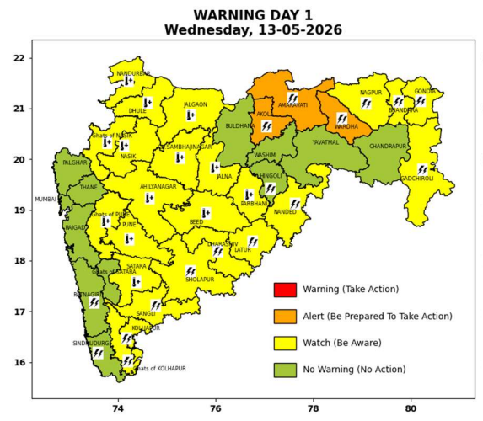 | 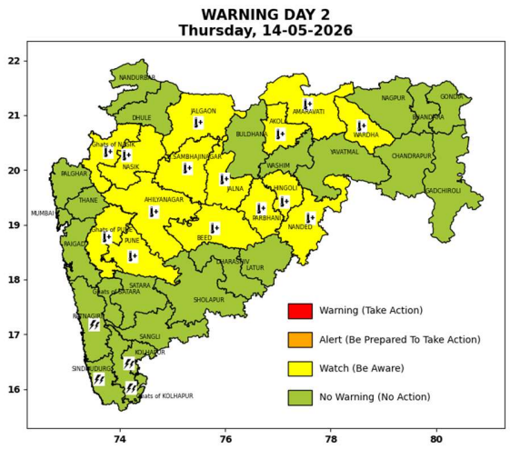 | 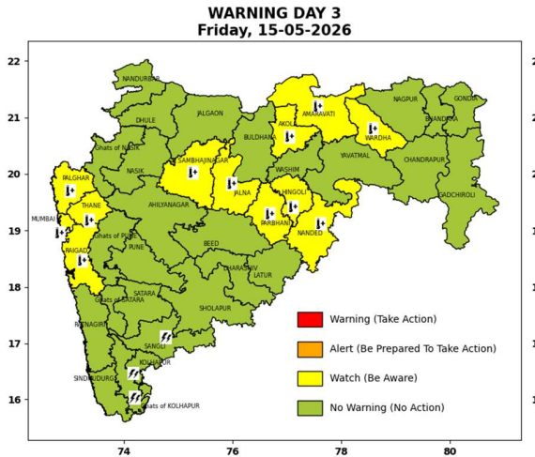 | 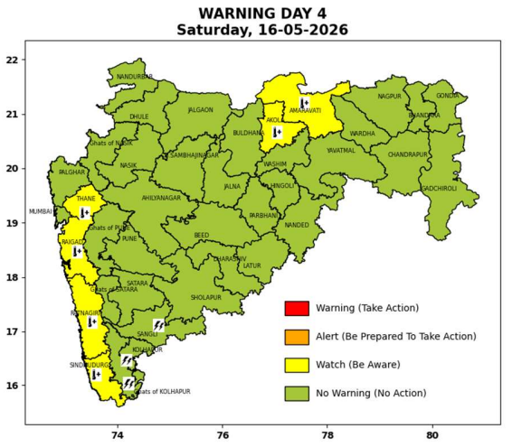 | 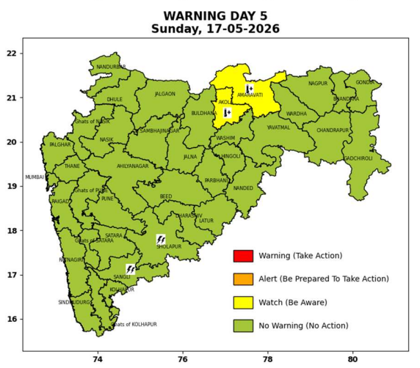

Pune, Lohegaon and Pashan observations at 0830 hrs. IST of Today
 | Temperature (°C) |  |  |  |  | Humidity (%) |  |  |  | Rainfall (mm)
 | Max.  past  24 hrs | Dep.  from  normal | Min.  past  24 hrs. | Dep.  from  normal | Dry  Bulb | At 0830 hrs. IST | Dep.  From  normal | At 1730  hrs. IST of y’day | Dep.  from  normal | Past  24 hrs. | Since  1st March | Dep.  from  normal
PNE | 40.8 | 3.3 | 27.4 | 5.1 | 30.4 | 50 | -5 | 37 | 3 | 0.0 | 92.8 | 70.9
PSN | - | - | - | - | - | - | - | - | - | - | - | -
LHG | 43.2 | 5.2 | 29.2 | 8.2 | 31.4 | 42 | -16 | 27 | -5 | 0.0 | 91.4 | 64.7

 |  |  |  |  |  |  | Local (Pune and neighbourhood) forecast
Max./Min. Temperature (°C) |  |  |  |  |  |  |  |  | Weather
Date | Pune | Pashan | Lohegaon | Chinchwad | Lavale | Magarpatta | NDA | Koregoan park
13/05/26 | 39 / 27.4* | 38 / 26.2* | 41 / 29.2* | 38 / 27.1* | 37 / 24.1* | 39 / 28.8* | 38 / 26.4* | 39 / 28.8* | Mainly clear sky becoming partly clear sky towards afternoon or evening.
14/05/26 | 40 / 27 | 39 / 26 | 42/ 29 | 38 / 27 | 38 / 24 | 40 / 29 | 38 / 26 | 40 / 29 | Mainly clear sky becoming partly clear sky towards afternoon or evening.
15/05/26 | 40 / 27 | 39 / 26 | 42 / 29 | 38 / 27 | 38 / 24 | 40 / 29 | 38 / 26 | 40 / 29 | Mainly clear sky becoming partly clear sky towards afternoon or evening.
16/05/26 | 41 / 26 | 39 / 25 | 43 / 28 | 39 / 26 | 39 / 23 | 41 / 28 | 39 / 25 | 41 / 28 | Mainly clear sky.
17/05/26 | 41 / 26 | 39 / 25 | 43 / 28 | 39 / 26 | 39 / 23 | 41 / 28 | 39 / 25 | 41 / 28 | Mainly clear sky.
18/05/26 | 41 / 25 | 39 / 24 | 43 / 27 | 39 / 25 | 39 / 22 | 41 / 27 | 39 / 24 | 41 / 27 | Mainly clear sky.
19/05/26 | 40 / 25 | 38 / 24 | 42 / 27 | 38 / 25 | 38 / 22 | 40 / 27 | 38 / 24 | 40 / 27 | Mainly clear sky.
Rainfall Distribution |  |  |  |  | Rainfall Categories | Rainfall (mm) | Cloud condition |  | Rainfall Intensity | Range
Widespread (W) | 76-100% |  |  |  | Very Light rain | Trace to 2.4 mm | Mainly clear sky | 1-2 oktas | Light Spell | 1 cm/hr
 |  |  |  |  | Light rain | 2.5 to 15.5 mm | Partly cloudy sky | 3-4 oktas | Moderate Spell | 1-2 cm/hr
Fairly Widespread (FW) | 51 – 75% |  |  |  | Moderate rain | 15.6 to 64.4 mm | Generally cloudy sky | 5-7 oktas | Intense Spell | 2-3 cm/hr
Scattered (S) | 26 – 50% |  |  |  | Heavy rain | 64.5 to 115.5 mm | Overcast | 8 oktas | Very Intense Spell | 3-5 cm/hr
Isolated (I) | 1 – 25% |  |  |  | Very heavy rain | 115.6 to 204.4 mm |  |  | Extremely Intense Spell | 5-10 cm/hr
Dry (D) | No Rain |  |  |  | Extremely heavy rain | ≥ 204.5 mm |  |  | Cloudburst | > 10 cm/hr
Probability Terms in %: |  |  |  |  | Heavy snow | 6.5 to 11.5 cms water equivalent of rain
unlikely | < 25 |  |  |  | Very heavy snow | 11.6 to 20.4 cms water equivalent of rain
likely | between 25 50
very likely | between 51 75
most likely | >75
* = realized temperatu
Mumbai (Colaba) |  |  |  | Nagpur (AP)
Date 2026 | T max °C | T min °C | Weather | T max °C | T min °C | Weather
13/05/26 | 35 | 28 | Clear sky. | 44 | 26 | Thunderstorm with rain. Thunderstorm accompanied with lightning & gusty winds(40-50kmph)
14/05/26 | 35 | 28 | Clear sky | 44 | 26 | Mainly clear sky
15/05/26 | 35 | 27 | Heat Wave. | 44 | 27 | Mainly clear sky. Heat Wave
16/05/26 | 34 | 27 | Clear sky | 43 | 26 | Mainly clear sky.
17/05/26 | 34 | 27 | Clear sky. | 43 | 26 | Mainly clear sky
18/05/26 | 33 | 27 | Clear sky. | 43 | 26 | Mainly clear sky
19/05/26 | 33 | 27 | Clear sky. | 43 | 26 | Mainly clear sky

